Welcome to our rural!
A participatory workshop for rural communities and stakeholders contributing to the European Commission’s initiative “A long term vision for rural areas” #rural2040 #RuralVisionEU

Workshop script

Background information
This workshop package is an opportunity for groups of rural citizens to explore their ideal vision for the future of their own rural area. It is one of the channels for rural people to contribute to the European Commission’s Communication on a Long Term Vision for Rural Areas.
It encourages rural citizens to think about what they would like their area to be, how it might change over the next 20 years, what developments they would like to see, and what enabling conditions are needed so that their area can become the place they dream of.
The package consists of a template for a two hour participatory workshop that can be organised and run autonomously by stakeholder groups throughout the EU, using a standard basic script, visual materials and a “harvest sheet” to record the workshop outcomes in a consistent format. All material is available to download at the ENRD Long Term Rural Vision Portal under Resources.
Given the current restrictions many places experience due to COVID-19, it has been designed as a process to be run virtually. However, if physical meetings are possible, it can easily be adapted to run in a physical setting, and tips on how to do this are included.
To be taken into account in the European Commission’s work on developing a Long Term Vision for Rural Areas, the results of your workshop (the workshop PowerPoint including input created during the workshop, plus, if you so choose, a short supplementary document) should be submitted by 31 January 2021 to EC-RURAL-VISION-WELCOME-TO-OUR-RURAL@ec.europa.eu .

Organising a virtual workshop

Preparation in advance
Find your co-host! It is definitely recommended to organise the workshop as a pair, it is much easier with two (or more) people. It is recommended that you have one person in charge of moderation and the other as technical support.
Read through the background and script and make any adaptations appropriate for your group and situation (e.g. you might feel it appropriate to focus more on certain of the characteristics, especially if you have a small group and/or very limited time).
Decide on the territory to be considered as “our rural area” for this exercise. It could be a village, a municipality, a mountain range, a Leader territory……whatever seems appropriate.
This workshop is designed to work with groups of up to approximately 25 people. Working as one group throughout is simpler, and is recommended for up to 12 participants. For groups larger than 12, it is recommended to split into three breakout groups for some sessions, as indicated in the script.
Download the workshop materials and adapt the PowerPoint (e.g. identify the territory that the workshop will consider, and if not using breakout groups add extra dots to the “wheel” slide of the PowerPoint so that there is one per person).
Prepare your virtual platform (with breakout groups if required) and practice your technical set-up in advance with your co-host.
Provide the visual canvas/wheel, driver cards and participants’ PowerPoint to all participants in advance.
[if using Slido/Mentimeter set up the wordcloud, and ideally insert the QR code and access code into PowerPoint Slide 5]

Virtual Workshop: Structure of the two hour session
General comments | - It is important to manage the time carefully to concentrate on identifying what is needed to fulfil the vision for your area, rather than spending too much time discussing the current situation.  - The timings below total 115 minutes (i.e. 5 minutes less than two hours) giving a 5 minute “buffer”  - Suggested script for the host is shown in italics

Timing | Process & Instructions |  | Material needed/ PowerPoint Slide
- Introduction (5 min)
5 min | Welcome by host.  Explanation of concept, purpose and programme of the workshop.  Show the slide 2 with the ‘workshop structure’.  For example:  We’re meeting today to think about our own rural area, and to explore together our vision for what it might be like in the future …. Say in 20 years’ time…. 2040.  This is part of the European Commission’s initiative to establish a Long Term Vision for Rural Areas. We are using a method developed by the Commission to provide a channel for rural communities, or other rural stakeholders, to feed in their views. This process will culminate with a virtual conference in March 2021, and a published “Communication on a Long Term Vision for Rural Areas” in June 2021. I’ll be sending back a summary of our discussions to the European Commission [if appropriate: and also to our National Rural Network] so that our views can be taken into account.  We are using participatory methods, conversations and groupwork - we will explore together, share our views, and exchange ideas. There aren’t right or wrong answers, we aren’t in competition, it is a free space to explore, exchange, imagine and co-create.  There is a lot to think about in a short time, so I would ask everyone to be disciplined, to respect each other and the time available, to listen carefully to others and to contribute ideas to the discussions. |  | - PPT Slide 1  - PPT Slide 2
- Ice-breaker: Our Rural Area (10 mins)
2 min | Agree on the territory being considered for this exercise to ensure shared understanding by all participating. The organiser should propose an initial definition/area (village, commune, municipality, region, mountain range, LAG area).  Let’s each think individually about our rural area for a couple of minutes. What is special about it for you? What makes you proud of this area? What word(s) would you use to describe what it means to you?  This helps us understand our area, and the things that matter to us, and what makes it a good place to live. |  | - PPT Slide 3  - PPT Slide 4
2 min | Quiet thinking
6 min | Gather feedback through building a digital word cloud and display it.  This could be done by typing participants’ contributions onto a  - PowerPoint slide, or  - By using a tool such as Slido or Mentimeter. If using one of these tools, you could take a screen shot and insert it into the PowerPoint Slide 11 (this means you will have a record of contributions). |  | - PPT Slide 5  - Slido or Mentimeter survey
3. Where are we going? (40 mins)
5 min | Participants are all together in one group for the initial explanations of content and process.  - Introduce the visual canvas/ wheel (on ppt slide 7 as below) and the eight groups of characteristics it includes. Explain that the centre represents a poor situation and the edge represents a good situation.  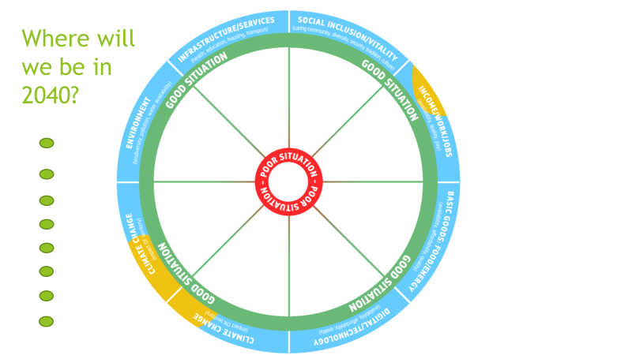  - Explain that we are going to explore possible futures for what our area might be like in 20 years (2040) in relation to these eight groups of characteristics.  - Ask participants to reflect on what they identified as special about their area: These special things will probably fit into one of the eight sets of characteristics on the wheel, and can serve as starting points for the next discussions.  - What shifts might happen from where we are today? What trends will influence changes? What have we already seen, or know about? Are current trends likely to become more pronounced, or less important for our area? Will they have negative implications or open new opportunities? The idea is to imagine what the future might be like…..  - Explain that the four driver cards can be used as prompts/discussion starters, to help identify what changes might occur in the next 20 years.  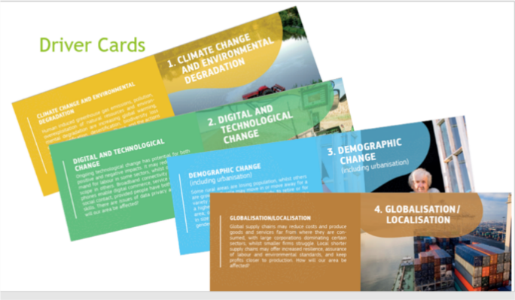  - Offer an example: (here is one example related to health services, you may prefer to use one more appropriate for your area) There can be both positive and negative influences. For example, by 2040, the development of digital health monitoring and diagnostic support has increased access to specialist health care. However, the continued decline in the local population has meant that the doctor’s surgery in the village has been closed. Climate change means that more people suffer from heat stress related illnesses in the summer. |  | - PPT Slide 6  - PPT Slide 7  - Visual canvas/ wheel  - Driver cards  - PPT Slide 8
35 min | This part can either be done all together (Version A), or divided into three groups (Version B). | Version A (all together)  - Each person in turn takes a characteristic (either the feature of the area they identified as special, in which case they should identify which section of the visual canvas/wheel it relates to, or another characteristic chosen from the wheel) and describes how it might change over the next 20 years. The others may comment/add.  - The driver cards can be used as prompts.  - The host moves a green dot from the left of the PowerPoint slide, onto the relevant part (“slice”) of the wheel and places it in the space from centre (poor situation) to edge (good situation) to represent the participants’ conclusions.  Note: it does not matter if not all of the eight sets of characteristics are covered, or if more than one aspect of one set is covered ( see example below – with two dots in the Environment segment, because biodiversity is expected to be in a better situation than water availability).  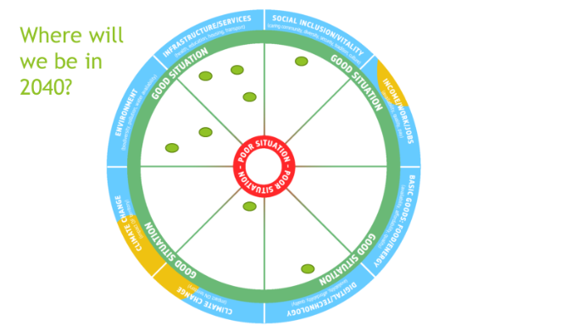 | - PPT Slide 10  - PPT Slide 9  - PPT Slide 10
Version B (3 breakout groups):
  - Explain that each of 3 groups will consider different parts of the wheel.
  - Group 1 considers Infrastructure/Services and Social Inclusion/Vitality.
  - Group 2 considers Income/Work/Jobs, Basic Goods: Food/Energy and Digital/Technology.
  - Group 3 considers Climate change (impact ON the territory), Climate change (impact OF the territory), and Environment.
  - Explain that each group should discuss the relevant segments of the wheel and consider how it might change over the next 20 years, and what the situation might look like in 2040.
  - The driver cards can be used as prompts.
  - Send the participants into the three virtual breakout groups for 20 min.
  - After 20 min, bring the groups back together.
  - Each group reports back in turn on the characteristics they have discussed, explaining where in the space from the centre (poor situation) to the edge (good situation) they would place it and why.
  - The host moves a green dot from the left of the PowerPoint slide, onto the relevant place on the wheel to represent the participants’ conclusions. (15 min – 5 min per group).
4. Where would we like to be? (20 mins)
20 min | Show the wheel with the likely situation in 2040, then the wordcloud (outcome of what makes our area special/what are we proud of).  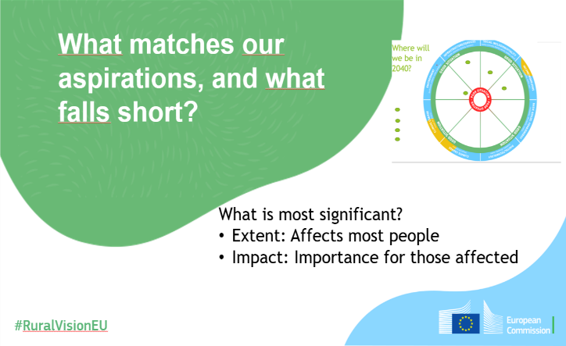  Insert the completed wheel into slide 12 “What matches our aspirations…”  (This can be done either by a screenshot/snip and sketch, or by inserting the wheel slide as a picture as above.)  Looking back on our initial thoughts, and reflecting on the possible situation in 20 years, What matches our aspirations, what falls short? Where are we likely to be in a good situation, and where furthest from a good situation?  The next stage is to identify most significant issues (those with greatest importance – having greatest impact on those affected, and those with greatest extent – affecting greatest number of people).  Identify the most significant gaps. What are the aspects that we would most need to address in order for our area to match our hopes and aspirations? Where are we furthest from the ideal situation represented by high scores for all characteristics on the wheel? As before, focus on those with greatest importance - greatest impact on those affected, and greatest extent – affecting greatest number of people.  Add the significant gaps identified to the PowerPoint slide 13.  Identify the characteristics with the greatest potential. Where are we most likely to be meeting our aspirations? What opportunities do we have to allow our area to develop to match our hopes and aspirations? Where do we have potential to move closer to a “good” situation (the edge of the wheel)?  Add the potential opportunities identified to the PowerPoint slide 14. |  | - PPT Slide 10  - PPT Slide 11 (or PPT Slide 5)  - PPT Slide 12  - PPT Slide 13  - PPT Slide 14
5. What are the enabling conditions to fulfil our vision? (30 mins)
30 min | This is a key part of the workshop, which seeks to identify what is needed to enable the territory to reach the vision and potential that the group has been imagining.  In this session we will focus on the characteristics with the most significant gaps that we have just identified, and those where there is the greatest potential to reach our aspirations.  Taking into account the current situation, the potential we’ve identified, the changes likely to occur in the next 20 years, and our desired place to be, what do we need, to take us to where we would like to be?  What pathways, actions, activities, support could we use to get to where we would like to be?  Think of stories or examples that we could draw on, adapt, or develop to match our own area and our own aspirations.  Complete the PowerPoint slide 16 with the enabling conditions identified, and inspiring stories. |  | - PPT Slide 15  - PPT Slide 16
6. Check-out (10 mins)
10 min | We are coming to the end of this workshop. We’ve thought about our area, and the outcome will be sent to the European Commission to feed into the Long Term Rural Vision Process – to get the voice of our area heard in Brussels. So far so good – that is already an achievement. But this is not a full stop, the end of a process. It is only one step along a path. What path, and where to? We have seen that there are many factors that influence our journey and our area. But it does not all depend on others – on “out there”, on the EU, on our capital, our region……we also can influence what happens, the path our area takes, and where we find our community in 2040.We can see from what we’ve produced that our community has energy, ideas, capacity, resources…… So, the final question to each of us today is:  What will be my next step towards fulfilling our dream?  Write participants’ responses on the relevant PowerPoint slide 17.  After the workshop, sent the PowerPoint including input created during the workshop (please don’t forget to complete the identifying details in Slide 19!) to EC-RURAL-VISION-WELCOME-TO-OUR-RURAL@ec.europa.eu by 31st January 2021. |  | - PPT Slide 17  - PPT Slide 18

Tips for adapting for use in a physical setting
The objective and structure of a physical workshop will be the same as for a virtual workshop. However, there are some differences, particularly related to preparation of the visual support material and the summarising the outcomes of the workshop. These tips are intended to help you if you are able to organise a face to face workshop.
Preparation for a physical workshop:
- Download and print:
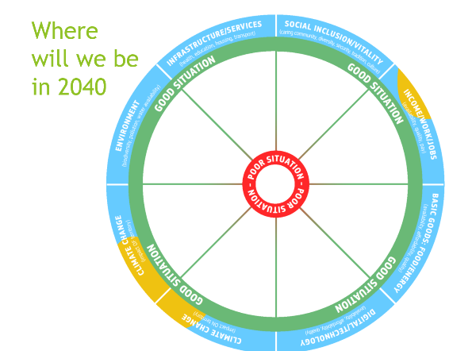
  - The parts of the visual canvas/wheel, and arrange the eight segments on a flip chart or other large piece of paper. Copy the headings from the A4 version.
  - The driver cards: print one set (four cards) for each table/small group.
  - An A4 copy of the visual canvas/wheel for each table/small group.
- Prepare flip chart sheets representing the slides from the PowerPoint to record the most significant gaps and opportunities, the enabling conditions, and stories/examples.
- You will also need flip chart paper, pens, and a supply of sticky dots.
- Decide whether to compile a digital word cloud – if not, prepare a flip chart sheet to record participants’ contributions.
- Set up the meeting room.
2. Ice-breaker: Our rural area
Stand in a circle. Build the word cloud on paper, writing the words spoken, or do it digitally and display on a screen – as for the virtual workshop.
3. Where are we going?
As for the virtual version, this session can either be done all together, or divided into 3 groups.
If done all together, everyone can gather round the large version of the visual canvas/wheel. The likely situation of the area in 2040 for each of the aspects discussed can be marked using sticky dots.
If done in groups, either participants could choose which group to join, or they could be assigned randomly (e.g. by drawing a number from a hat). Each group/table should have an A4 printed version of the visual canvas/wheel, on which they mark where they think their area is likely to be in 2040 for the characteristics they are discussing. When the groups come back together, each group puts sticky dots onto the one large visual canvas/wheel in the appropriate places. If there is time, once all groups have placed their markers on the large wheel, reflect on the pattern, encourage questions and discussion and aim to come to a consolidated view of the likely future situation. If there are diverging views, these could be marked using a variety of sticky dots, and you could add explanatory notes to the wheel.
4. Where would we like to be?
- In a physical setting, this will be with all the group together, in a circle around the visual canvas/wheel and with the word cloud visible. Do this collectively, as it is important to share ideas and aim for a common view in this section.
- When gaps and potential opportunities are identified, write them on flip charts.
5. What are the enabling conditions to fulfil our vision?
- This could be done with the whole group, or in smaller groups which then report back, with the outcomes being written on flip charts.
6. Check-out
- Bring everyone back into a circle, with someone prepared to note down participants’ contributions.
After the workshop, transfer the outcomes onto the “harvest/results sheet” from the downloadable package, and send it, together with a photo of your visual completed canvas/wheel and your wordcloud to EC-RURAL-VISION-WELCOME-TO-OUR-RURAL@ec.europa.eu .

Additional resources to support workshop organisers
A wide range of resources are available to support engagement with stakeholders, organisation of on-line meetings, hosting participatory workshops etc.
Some that may be useful in preparing to organise a “Welcome to our rural!” workshop include:
- ENRD Portal on the Long-Term Rural Vision, Resources section: Tools for engaging rural society
- This includes links to a series of guidance sheets prepared for the H2020 SHERPA project:
https://rural-interfaces.eu/resources-and-tools/stakeholder-engagement-tools/
- Tips on running participatory workshops:
https://www.artofhosting.org/
http://www.lupinworks.com/roche/workshops/2-techniques.php

Depending on the Member State, there may also be additional channels interested in receiving the outcome of your workshop (e.g. the National Rural Network, or the Commission’s Representation or Europe Direct Information Centre)
Depending on the Member State, there may also be additional channels interested in receiving the outcome of your workshop (e.g. the National Rural Network, or the Commission’s Representation or Europe Direct Information Centre)
Depending on the Member State, there may also be additional channels interested in receiving the outcome of your workshop (e.g. the National Rural Network, or the Commission’s Representation or Europe Direct Information Centre)

